No. 84 Bus Route
Just to let everyone know that we are still negotiating with the powers that be to have this bus route changed back to calling through Crawley Down. We have heard nothing from our Cabinet Member, John O’Brien and, as one of our local Mid Sussex Councillors, Neville Walker has taken up the cudgels in support of our efforts, he has liaised with the Chairman and the Secretary of the Residents Committee, together with Councillor Bruce Forbes, and has assisted us in drawing up a letter to our new MP, Jeremy Quin. This letter has now been sent off and we await a response. We continue to hope that something will come out of this. Further information in our next Newsletter.

Office E-Mail
Please remember that, if you have any problems or concerns, you should always, in the first instance, write to the Park Office and, if you get no satisfaction from there, then you can drop a letter to the Residents Association. If you find it more convenient, you can contact the Office by e-mail and the address is: - turnershilloffice@berkeleyparks.co.uk.

These Pesky Critters
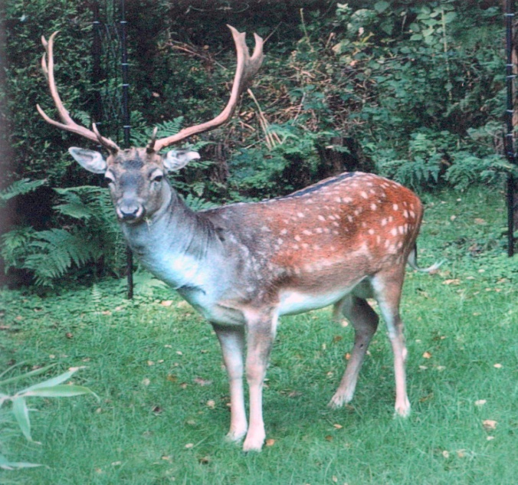
You will probably all know by now that the deer are back again. They leave their little calling cards all down my path and their hoofprints across the garden. So far I have been lucky and have not lost any of my plants but there are residents who have suffered quite badly. I suppose the shoots they nibble would be much the same as chocolate to us. Lovely but deadly.



NEWSLETTER
Turners Hill Park Residents Association

September 2015




Chairman’s Report
We completed our subscription collections at the end of June and have written to Berkeley Leisure to confirm our ‘Qualified Residents Association Status’ advising them that we calculated a 92% membership. The Director has now come back to us and confirmed acceptance of our status. This is a truly marvellous membership and I think that I am correct in saying that we have one of the largest memberships in the country. Our thanks go to you all for your continued support. Sometimes residents ask why we always ask that they contact the park office in the first instance and only if they get no response should they contact us by letter. This is the advice that we have received from IPHAS. They have advised that we can only make representation if a member has received no satisfaction from the park owners or if a group of resident members suffer the same complaint. You will recall that, in the June newsletter, I wrote about road markings. I have since heard from the Director who has advised that it is intended to carry out this work after planned road repairs later this year.
Finally, I would like to say a few words about our President Geoff Furzer. As most of you will have heard by now, Geoff passed away on the 5th September after many months of illness. Geoff was a champion of Park Home living; he was Chairman of our Association for 9 years and also an advisor with IPHAS since 2001. In addition, he was a Parish Councillor from 1996 – 1999. Since his death, many residents have spoken to me of their gratitude to Geoff for the advice and, in many cases, active assistance that he has given to them. I have passed all these comments on to Linda. He will be very much missed.
Geoff’s request was for a quiet private funeral. There will be no flowers but, if you wish, you could donate to Canine Partners, Midhurst in his memory. The Committee send their best wishes to Linda at this time.

A Message from Linda
I would like to thank all those who have very kindly sent cards to me following the death of my husband Geoff. I have been truly overwhelmed by the many messages of sympathy, and also the many tributes to Geoff regarding his advice and support of residents both during his time as Chairman of the Residents Association and as Advisor with IPHAS.
Linda Furzer

Florrie’s Barbeque
Florrie’s Barbecue went off very well indeed, despite the wet weather. Many thanks go to everyone who helped and aided her this year.

September Coffee Morning
Thanks to all who attended the coffee morning on the 7th September, sadly the numbers were somewhat low, but those who joined us, had a good time and we were pleased to welcome new residents. We wonder whether there may be some subjects that you would like us to find speakers or information to present at our mornings. Any suggestions are welcome and please do come to our Christmas morning, further details to follow.

Speed Watch
There is nothing to report at this time as the Speed Device is back to base for its annual service. Hopefully we will get in some sessions before the Winter sets in.

No Cold Calling Zone
Our No Cold Calling Zone is working well and we are getting numerous e-mails from Trading Standards and the Police advising us ‘to continue to be diligent’ about strangers trying to sell us items which we don’t want. If you have registered to receive any information from the Residents Association via e-mail, then you will be in receipt of some or most of the scams which are about at the moment. These unscrupulous people sound so plausible it is easy to be taken in but remember, if a deal sounds too good to be true, it probably is so don’t be drawn in. Check around first. One of our residents was told that he had won a considerable amount of money and to send off an administration fee to receive the sum involved. How easy it is to be hoodwinked. Be warned and take care.

Hospital/Doctor/Dentist Appointments
Please remember that, if you need transport to any of the above, you can ring the Bluebird Community Transport on 01444-471919 or Crawley Community Transport on 01293-657080. There will, of course, be a charge involved but you may find that it is cheaper than public transport.

Don’t Tolerate Anti – Social Driving - Report It
Have you witnessed any of the following anti – social driving?
· Speeding
· Thoughtless Driving
· Underage Driving
· Drink or Drug Driving
· Mobile phone use
· Unlicensed or Uninsured Driving
· Driving without a seatbelt

If you do please contact Sussex Police at the time of the incident or report it via Operation Crackdownwww.operationcrackdown.org

